### Java Fundamentals 7-1: Classes, Objects, and Methods Practice Activities

### Vocabulary Definitions

1. **Class**: A template used for making Java objects.
2. **this**: An optional keyword used to access the members and methods of a class.
3. **Object**: An instance of a class.
4. **new**: The operator used to create an instance of a class.
5. **Garbage Collection**: A built-in function of the Java VM that frees memory as objects are no longer needed or referenced.
6. **Mutator Method**: A method that changes the state of an object.
7. **Accessor Method**: A method that returns information about an object back to the calling program.
8. **Method**: A procedure (changes the state of an object) or function (returns information about an object) that is encapsulated as part of a class.
9. **Instantiate**: A verb used to describe the act of creating a class object using the keyword new.
10. **Initialization**: The process of assigning a default value to a variable.
11. **Null**: An object reference that has not been instantiated.
12. **Finalizer**: An optional method that is called just before an object is removed by the garbage collector.
13. **Instance Variable**: The name of a variable that is associated with an object.
14. **Constructor**: A special method used to create an instance of a class.

### Practice Activities

1. **Shape Class**

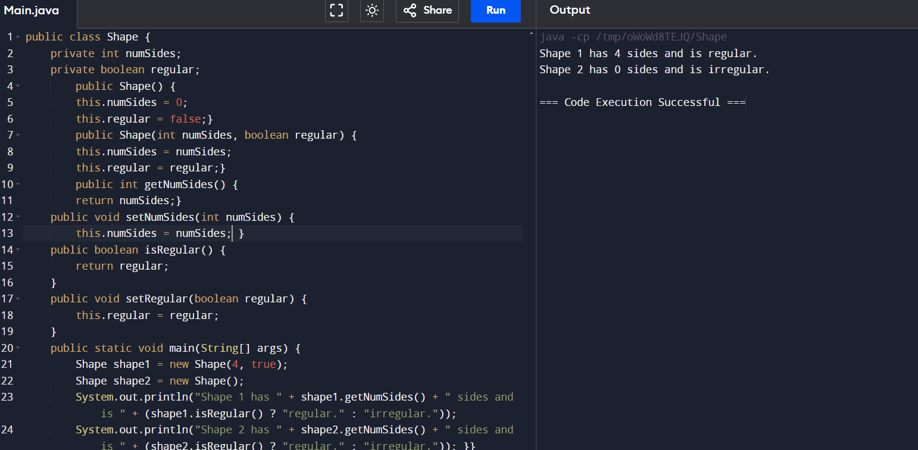

1. Identifying Key Parts of the Java Class

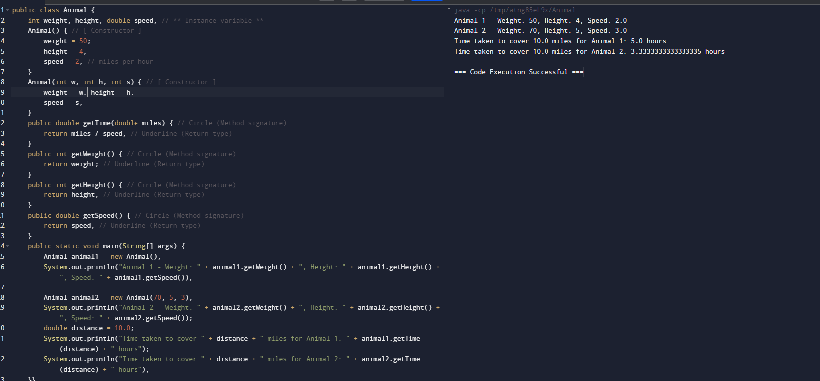

1. Creating Instances of Animal

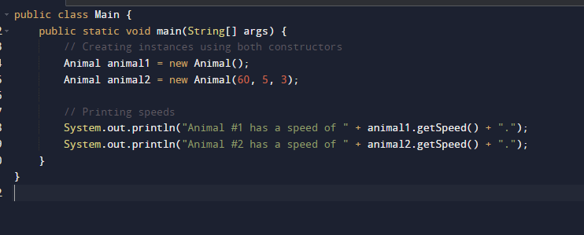

1. Student Class

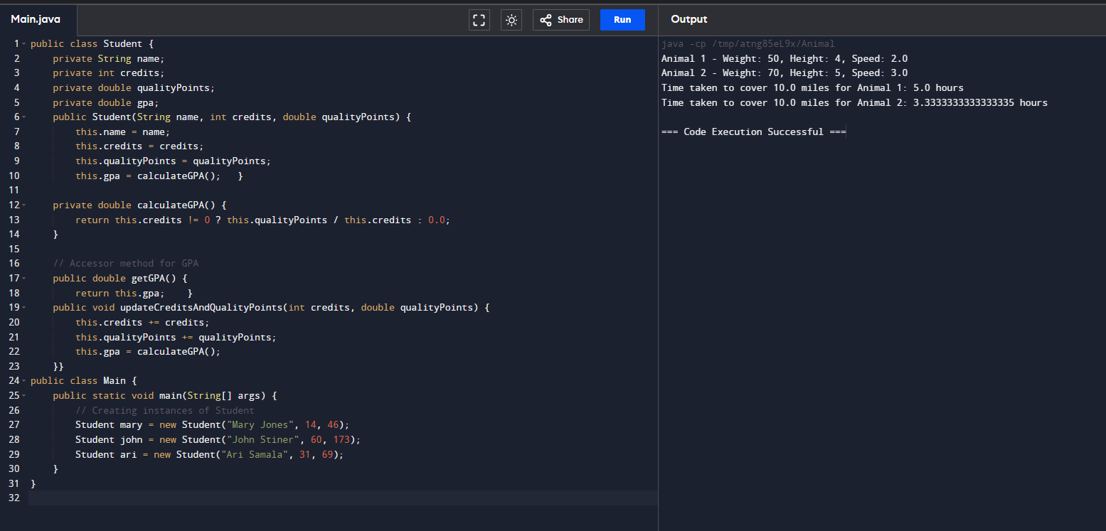

1. Creating Instances of Student

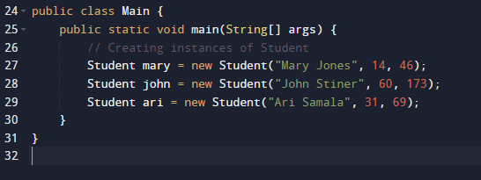

1. Updating Credits and Quality Points for Ari Samala

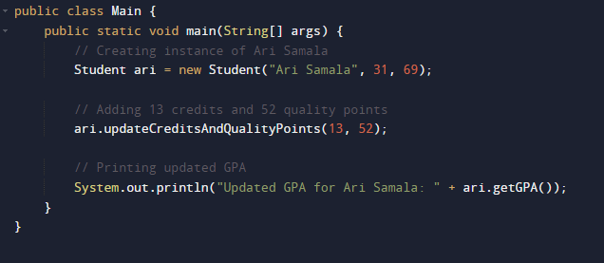

1. Card Class

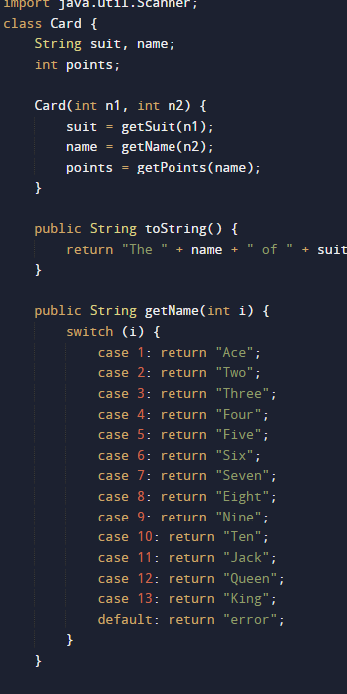

1. Main Class with Additional Card Logic

